(Approx. 2089 words)

How to Find Files
By Al Williams, President
Willow Valley Computer Club
wvcomputerclub (at) gmail.com

Introduction

Did you ever want to find a file, but you couldn’t remember where you put it? Or, perhaps you couldn’t remember all of the file name?

There are ways to find files on your device.
Whether you have an iPhone, iPad, Android, Linux, or Windows device, they all have utilities to help you find files. Windows has a built-in search function, but it doesn’t allow specially designed searches. In this article, I’m going to describe the tool known as Everything, which quickly finds files and folders on Windows devices, allows specially designed searches, and shows all possible search results. Several residents have tried this tool and like it. I think you’ll find it very helpful. I’ve written the article for those who are completely new to Everything, those who have experience and wish for an intermediate understanding, and those who would like an explanation of Everything’s advanced features. I’ll provide information about utilities for other operating systems at the end of this article.

This section is for those who are completely new to Everything.

What is Everything?
Everything is a free utility that finds files or folders. It can also find a file that contains user-specified text.

How do I install Everything?
Everything is found at https://www.voidtools.com The webpage shows multiple ways to download Everything. For most users, the Download Installer 64-bit choice is best. You download the file and then install it by double-clicking the filename. However, if you wish to try it without installing, then the best choice is Download Portable Zip 64-bit. You could use the popular 7-Zip program to unzip this download to use it; however Windows has built-in unzip capability in Windows 10 at or and Windows 11 at. If you choose to install, Everything installs in the same way as other programs.

How do I open Everything?
Once installed, an easy way to open it is to type Everything into the Search field, as shown in the following window. I am using a dark theme. Your window will look similar but may have different colors.

If you are using the portable version of Everything, you will not be able to find Everything by typing Everything into the search window. Instead, you’ll need to find the folder containing the unzipped Everything app and double-click the app to open Everything.
Then, click on the Open option. See below.
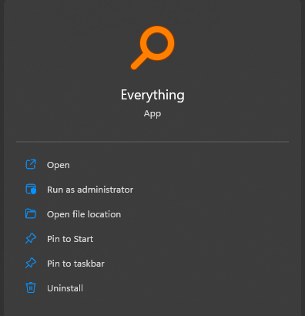
Initially, you may not see anything in the Everything window as Everything updates its database by finding all the files on your computer. After it has found the files, a window similar to the window below will appear. The files that will be listed in your Everything window should be very different from the files in my computer which are listed below.
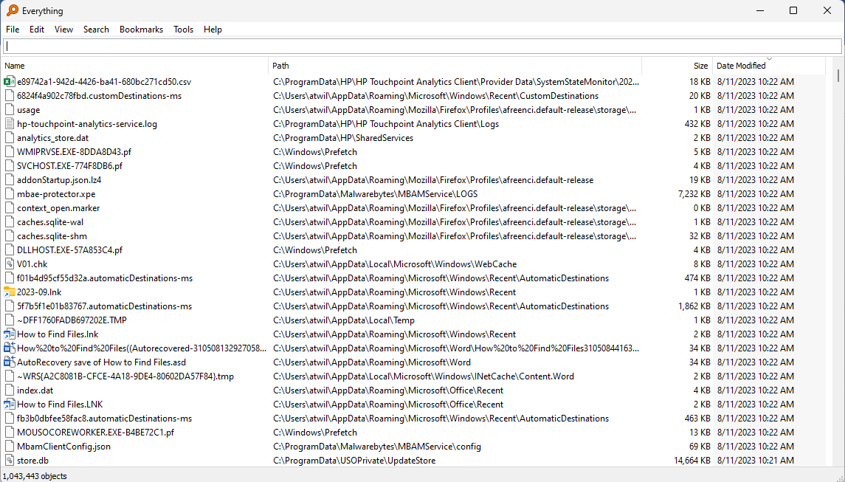
If you look at the bottom left-hand corner of the above window, you’ll see that I have over 1 million files on my computer’s hard drives and my external hard drives. Everything states in their FAQ webpage that it takes about a minute to find 1 million files. You very likely have a smaller number of files, and Everything will not need a minute to find all of your files.

How do I use Everything?
To demonstrate how Everything works, I’ve created these files on my computer and put them into a folder named Everything Demo C Drive.
Testfile.docx
Testfile1.docx
Testfile10.docx
Testfile11.docx
Testfile2.docx
Testfile21.docx
Testfile23.docx
Testfilea.docx
TestfileZ.docx
To understand this tutorial, it would be good to either install Everything or use the portable version of Everything and follow the below steps.

When I enter Testfile into Everything’s search box, this is the window I see on my computer.
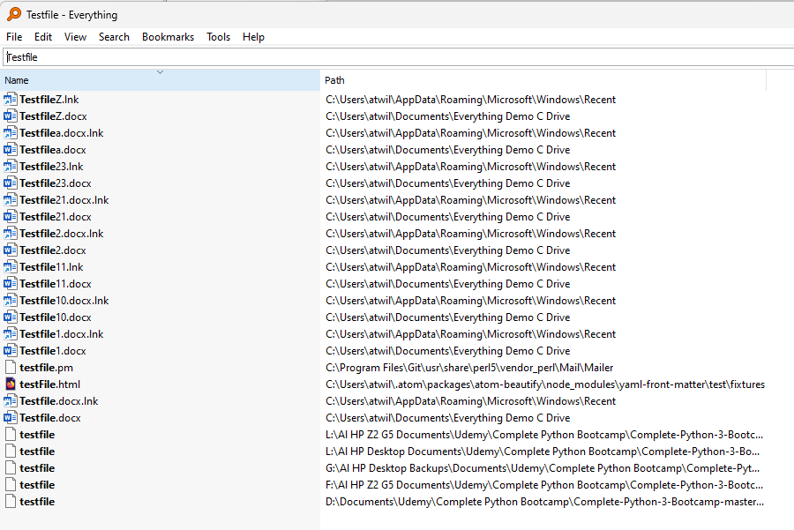
The above window shows that Everything will display only the files that contain the characters Testfile in the filename. You can, of course, search for any characters in a filename.

You’ll notice some link files that Windows created in addition to the files I created. In addition, I’ve taken a Udemy course which also uses a file named testfile, which appears at the bottom of the window. While looking at the window, note that the Udemy testfile is in another hard drive on my computer, the D: drive, and on two external hard drives, G: and L: Everything will also display files on flash drives. This window shows that Everything has searched for all files on my computer.

I can cause Everything to display only the .docx files, that is, to not include the .docx.lnk files, by typing in the search field a few spaces, then Documents\, and then Testfile. The Documents\ instructs Everything to look only in the Documents folder. You could use a different folder for searching, such as Videos\ or Pictures\. In all cases, the \ symbol indicates that Documents, Videos, or Pictures is not the name of a file but rather the name of a folder. The result of adding Documents\ is shown in the next window. The .lnk files are no longer displayed.
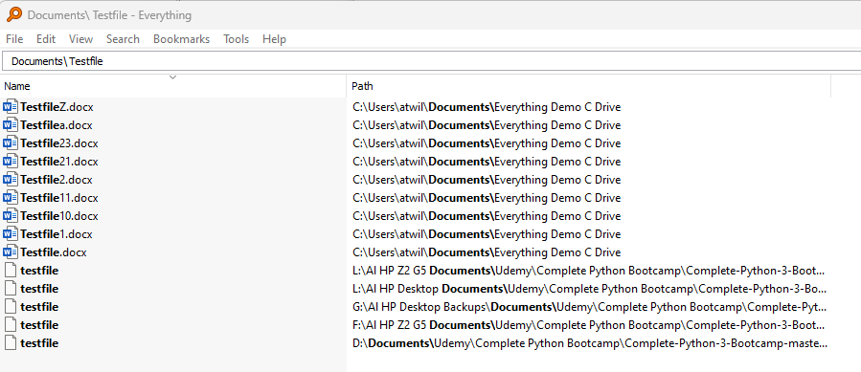
However, at the bottom of the screen are the multiple testfile entries from other drives on my computer. Those files are also inside a Documents folder on those drives. I can choose which hard drive I want to view. In this case, I want to view only files on my main hard drive, the C: drive. The below window shows how to add the C: drive criteria and the resulting search.
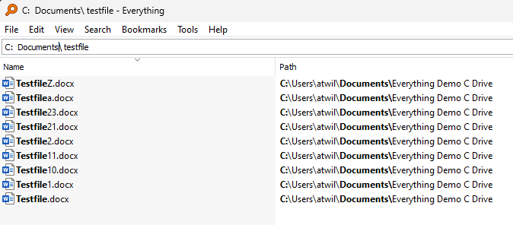
The above search is called an AND search. It says: Search only the C: drive. Then, search only the Documents folder that is in the C: drive. Finally, it says to find all possible Testfile files in the Documents folder. You could reverse the thought process by saying that you are going to find all Testfile files that are in the Documents folder that is on the C: drive.

Instead of instructing Everything to use the Documents\ to find the files, I could use another folder. Let’s try using the folder containing the testfiles, Everything Demo C Drive. The below window shows the results when I replace Documents\ with Everything Demo C Drive\.
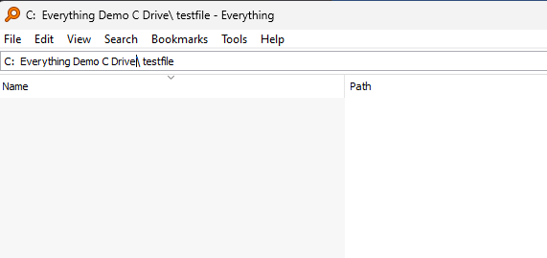

There are no results. That’s because Everything understands that a space separates file names or folder names that are part of an AND search. If I enclose a folder name or a file name that includes spaces with quotation marks, then Everything sees the entire quoted string as a file name or folder name. In this demonstration, the search using the Everything Demo C Drive folder is shown below. Note that the \ symbol indicating a folder is immediately after the quotation mark.
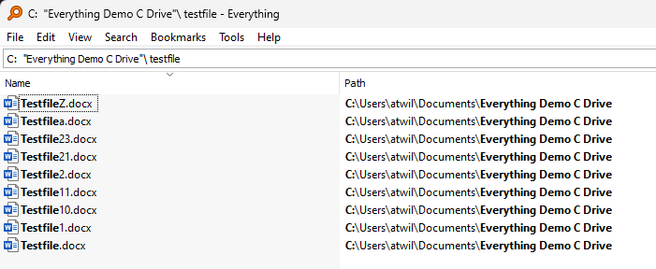

The above completes the demonstration of a normal search..

Normally, the above technique will find all the files you’re looking for because, usually you’ll be looking for just a few files.

This section is for those who would like an intermediate understanding of Everything.

Advanced Search

However, if the above normal search technique shows many files and you need help finding a specific file or set of files, Everything offers two ways to do so. It offers a feature called Advanced Search and it offers another feature called Regex. To get to the Advanced Search window, click on Search on the menu bar and then click on Advanced Search. See the window below.
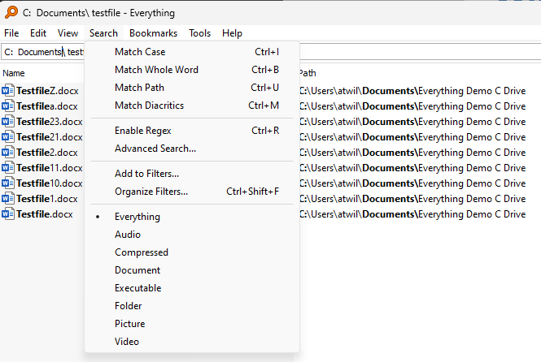

Advanced Search – Finding Files
After you click on Advanced Search in the menu, the Advanced Search window is displayed. See below.
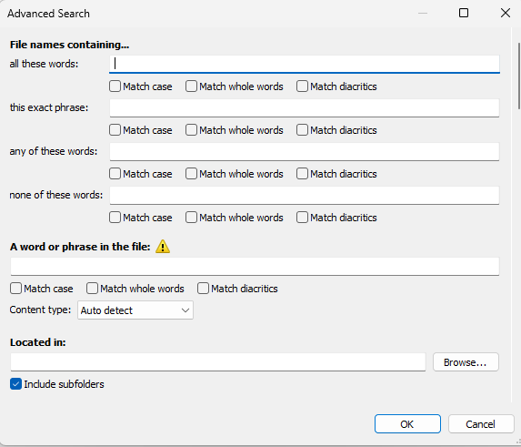

The Advanced Search offers many ways to find files and folders. I think that the user interface is very easy to understand, and I recommend that you explore Advanced Search by trying its options.

Advanced Search – Finding a file that has the desired text
Advanced Search also offers a way to search for a word or phrase in a file as shown in the bottom part of the Advanced Search window. This search is very slow. You should restrict the search to just a few files so that a result is displayed in a reasonable amount of time.

This section is for those who would like an advanced understanding of Everything.

Regex
The way to do an even more advanced search is to enable a feature called Regex by clicking on Search in the menu and then clicking on Enable Regex. Regex stands for regular expression. See the next window.
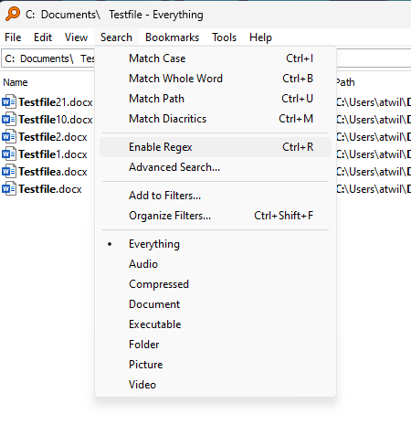
Once Regex is enabled, the search technique changes. If you look at the next window, you’ll see that our previously used search phrase finds nothing.

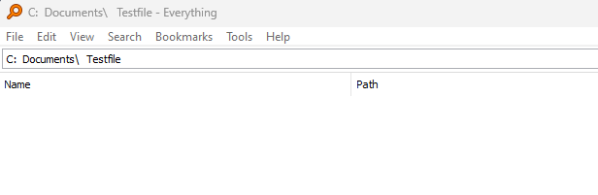
That’s because RegEx requires a more specific search statement. It needs the path to the folder holding the files to be searched. The next window shows the path on my computer. On your computer, the path will be shown in the windows that are displayed using the earlier search technique. Please note that the \ character is a special character in Regex. In order to use \ to specify folders, the \ symbol must be escaped by using \\. The window below shows all the possible Testfiles while using Regex.
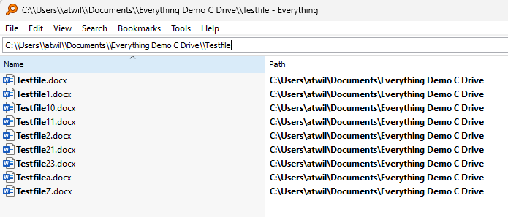
We can now use special characters to manipulate our search. Everything has a web page that describes the usage of Regex and these special characters at https://www.voidtools.com/support/everything/searching/#advanced_search. You may find the page confusing at first, but try the features and you’ll soon have an understanding.

Let’s assume we want to use Regex to find files that include the numbers 1 or 2. That is, we want to find files whose file names include these text strings: Testfile1 and Testfile2. The below window shows how.
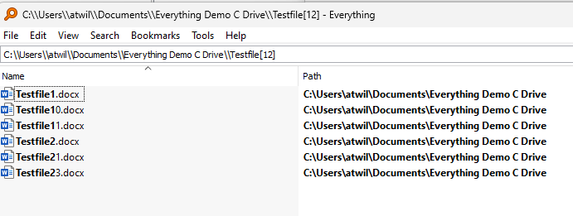
The [12] means that either the character 1 or the character 2 may be added to the string Testfile to create Testfile1 or Testfile2.

The window above shows the files that contain the strings Testfile1 and Testfile2 in bold. Let’s assume that we want to select only the Testfile1.docx and Testfile2.docx files. We do not want to include the Testfile10.docx, Testfile11.docx, Testfile21.docx, or Testfile23.docx files. We can do so by making the search more restrictive by adding .docx to the search, as shown below.
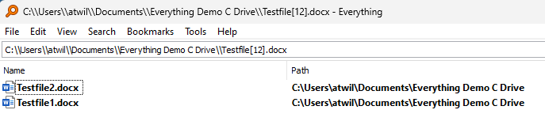
We can do many things with Regex. For instance, we can select Testfile11, Testfile21, and Testfile23 using this search:
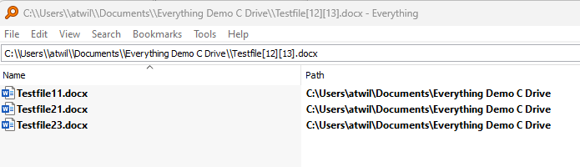
This search states that the character right after Testfile may be either 1 or 2, and the character after that may be either 1 or 3.

A way to state that a character may be a number, lower-case letter, or upper-case letter is to use this search statement: [0-9a-zA-Z]. The below window shows a search using this technique:
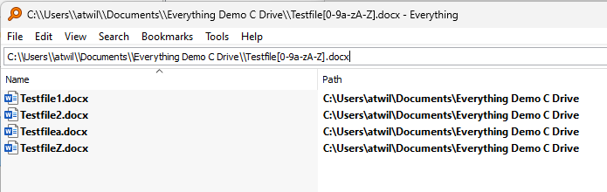
As you can see, with Regex you have significant control when finding files.
If you want to exit the Regex feature in order to use Everything in its normal mode, click on Search in the menu toolbar and then click on Regex to deselect it.
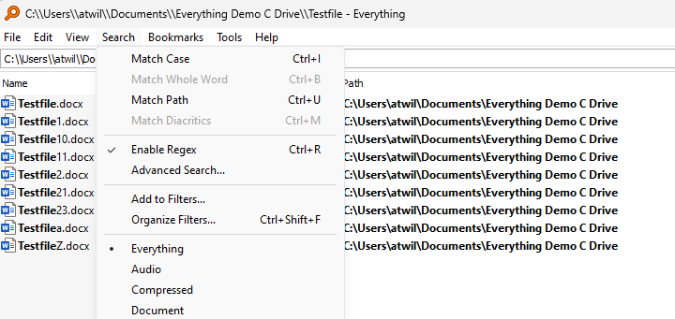

File finding utilities for other operating systems
As I stated at the beginning of this article, other operating systems also have file finding utilities. I won’t go into detail about their usage but will cite references where you can learn more.

For Linux, files are found using the find and locate utilities. If you are using a Linux distro, you may learn how to use either by issuing the man find or man locate commands. The man pages are terse, and tutorials are frequently helpful. Digital Ocean has a comprehensive tutorial here.

To find a file on Mac, do one of the following: 1) Use Spotlight to quickly find apps, documents, emails, and other items on your Mac. Apple has a support page for Spotlight here; or 2) Search from a Finder window, the default file management system of macOS. Apple has a support page for Finder here. In both Spotlight and Finder, you can use advanced searches to narrow your search results.

Apple describes how to find files on an iPhone or iPad here.
Android has many file finding utilities in the Google Play Store. The Tom’s Guide website lists 20 Android file managers, which they consider among the best. Some are free, and some require payment. You should find one that is satisfactory. Android also has its own way to find and delete files, as documented here. If this Google article is too brief, How-To Geek has two articles: how to find downloaded files and how to manage files and use the Android file system.

Summary
Knowing how to use your device’s software utilities to find and manage files is important. This article focuses on a specific utility for Windows, Everything, which can make searching for files on Windows much easier than the Windows’ search utility.

7-Zip, https://www.7-zip.org/
How to Zip (and Unzip) Files on Windows 10, https://www.howtogeek.com/668409/how-to-zip-and-unzip-files-on-windows-10/
Zip and unzip files, https://support.microsoft.com/en-us/windows/zip-and-unzip-files-f6dde0a7-0fec-8294-e1d3-703ed85e7ebc
How to Zip and Unzip Files on Windows 11, https://www.howtogeek.com/749206/how-to-zip-and-unzip-files-on-windows-11/#how-to-extract-a-zip-file-in-windows-11
How To Use Find and Locate to Search for Files on Linux, https://www.digitalocean.com/community/tutorials/how-to-use-find-and-locate-to-search-for-files-on-linux
Find files on your iPhone or iPad in the Files app, https://support.apple.com/en-us/HT206481
Best Android file managers, https://www.tomsguide.com/us/pictures-story/518-best-android-file-managers.html
Find and delete files on Android, https://support.google.com/android/answer/9110661?hl=en
How to Find Files You Downloaded on Android, https://www.howtogeek.com/689303/how-to-find-files-you-downloaded-on-android/
How to Manage Files and Use the Android File System, https://www.howtogeek.com/202644/how-to-manage-files-and-use-the-file-system-on-android/

